Computer simulation of formation of carbon fullerenes
Alexander I. Melker, Sergei N. Romanov, and Dimitri A. Kornilov
Department of Metal Physics and Computer Technologies, St. Petersburg State Technical University
Polytekhnicheskaya 29, 195251, St. Petersburg, Russia
e-mail: NDTCS@spes.stu.neva.ru, melker@twonet.stu.neva.ru

ABSTRACT
In this contribution, we report on a study of the growth of fullerens and carbon nanotubes from small clusters. A key factor in molecular dynamics modeling is the choice of interatomic potential. Ab initio molecular dynamics requires extensive computer resources, so that is outside the scope of most complex systems. We have developed simpler molecular dynamics model of charges at bonds which takes into account the electronic and atomic degrees of freedom and which can be implemented using a personal computer. Our approach has the possibility of studying the excited states formed by electronic transitions. The fundamental difference is that previously one considered only an atomic subsystem whereas now we have investigated both subsystems, atomic and electronic, simultaneously. We have found that the cluster growth is accompanied by the resonance of the electronic and atomic degrees of freedom.
Keywords: charges at bonds model, fullerene, molecular dynamics.

1. INTRODUCTION
The term "fullerene" refers to the molecules such as C₂₈, C₃₂, C₄₄, C₅₀, C₅₈, C₆₀, C₇₀, C₇₂, C₇₈, C₈₀, C₈₂, and so on, in which all the carbon atoms are on a spherical or spheroidal surface[1, 2]. In these molecules the carbon atoms are located in the vertexes of exact hexagons or pentagons that coat an orb or spheroid surface The major interest in the fullerene molecules is explained by the fact that they have a series of unusual properties. At the same time, the problem of fullerene nucleation and growth is of special interest for practical use as a new material. Several groups have tried to understand the mechanism of fullerene formation using different approaches that can be divided into two types:
- mental rather sophisticated picture models,
- speculative models based on computer simulations.
The picture models are very interesting but they have no mathematical basis. The shortcoming of this approach is that the final structure is specified in advance. Molecular simulations can predict sometimes cage structures. However, all these simulations enforced particular boundary, initial, or formation process conditions in order to make the caged structures. As far as we know, no simulation has been able to obtain a perfect fullerene structure at laser irradiation temperature (1000-1500 K) or at arc discharge temperature (1000 K).
In this contribution, we consider a new molecular dynamics method, a model of charges at bonds, which takes into account the electronic and atomic degrees of freedom. Our approach gives the possibility of studying the excited states formed by electronic transitions. The fundamental difference is that previously one considered only an atomic subsystem whereas now we investigated both subsystems, atomic and electronic, simultaneously. As a result, we were able to obtain the caged structures of fullerenes in the range of C₂₄ to C₆₀ .
2. SOME PICTURE MODELS
2.1. Fullerene assembly from graphite fragments
In this model, it is supposed that C₆₀ is agglomerated from a graphite stratum at ablation of flat leaves. The elementary expedient for such assembly is the linking of six clusters C₁₀ with the structure of double hexagons. A graphite leaf in the shape shown in Fig. 1 is folded in a cup, a half-fullerene C₆₀, that is growing into a whole fullerene C₆₀ by joining smaller fragments of graphite.
2.2. Limacon model
According to this model, a carbon cluster in the form of an uncurved leaf grows and folds in such a way as to minimize the number of free connections. The growth of a carbon cluster in this model is similar to that of a limacon (Fig. 2). A part of growing clusters transforms gradually into fullerenes, the remaining one grows as soot particles with a spiral structure.

Fig. 1. A flat fragment of graphite which is folded in a cup ( half fullerene C₆₀.).
The dashed lines show connections that will be deleted at folding.

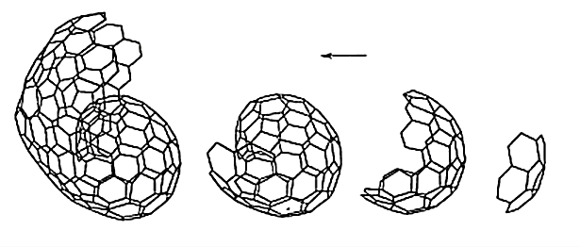
Fig. 2. Growth of a carbon cluster in the limacon model.

2.3. Assembly from rings
According to the isolated pentagon rule, a growing leaf bakes out in such a manner that pentagons are parted by hexagons, and this process gives fullerenes in the end (Fig. 3).

C₁₀ + C₁₂ + 2C₁₈ + C₂ = C₆₀
C₁₀ + C₈ + C₂₀ + C₁₆ + 3C₂ = C₇₀
2C₁₀ + 2C₂₀ + C₂₄ = C₈₄

Dominant number of clusters, larger than C₃₀, contain only even number of atoms, therefore the isolated pentagon rule was supplemented by the guess that the C₆₀ growth happens as a result of sequential affixment of C₂.
2.4. Fullerene road
In the fullerene road model, it is suggested that clusters grow as linear chains up to C₁₀ , rings for from C₁₀ to C₂₀ , and become fullerenes at 30 - 40 atoms in a cluster. The further growth of a cluster is ensured by successive parenthesizing of a C₂ microcluster (Fig. 4).
There is a good many other picture models of fullerene formation. Each model explains some experimental results and allows make qualitative conclusions concerning the fullerene formations. However, this approach cannot be a basis for nanostructure technology that needs quantitative analysis to find the optimum conditions for synthesizing fullerenes and nanotubes.

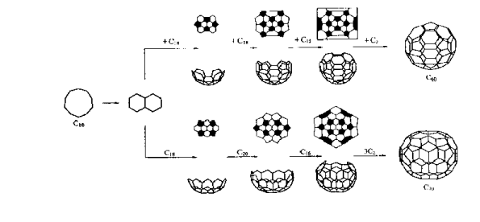
Fig. 3. Formation of fullerenes according to the assembly-from-rings model.

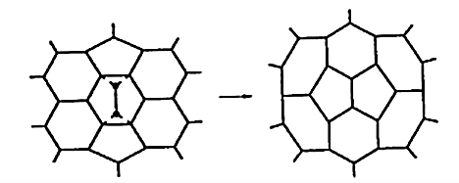
Fig. 4. Parenthesizing of a C₂ microcluster in a fullerene.

3. TRADITIONAL MOLECULAR DYNAMICS MODELS
The picture models considered above illustrate the possible mechanisms of folding but they cannot answer the basic question why the folding occurs. Well-developed traditional methods of theoretical physics are of little use in this case because the many-body problem of self-assembly is nonlinear. Therefore recourse to computer simulation is warranted. A brief review [3] of the few in number efforts to understand the formation mechanism using molecular simulation shows that no simulation has been able to achieve a perfect fullerene structure. We will consider only one typical recent example [3, 4] in detail keeping in mind that other computer simulations are similar and may differ to only a small extent.
Five hundred carbon atoms in gas phase with random positions and velocities were distributed at temperature 3000 K in a 342 Å cubic box with periodic boundary conditions. At 500 ps, some clusters formed chain or ring structure around C₁₀ ; at the same time many carbon atoms were in the form of isolated atoms, dimers, and trimers. At 1000 ps, one of the largest clusters grew to a C₃₃ cluster. At 1500 ps, a C₅₃ cluster of almost closed caged structure appeared; at 2000 ps, it transfromed to a C₆₀ cluster. Finally at 2500 ps, the largest cluster had grown to C₇₀ with almost closed caged structure and there was another spherical C₅₈ cluster (Fig. 5).
The authors have also studied the influence of a temperature on the final structure of the largest clusters using a smaller system of 200 atoms in a cubic box of 80 Å (Fig. 6). At 1000 K, the cluster was almost flat; at 2000 K, the cluster was made of two flat structures merged together; at 2600 and 3000 K, imperfect hollow caged structures were observed; at 3500 K, the cluster had a random bulky structure including some carbon atoms in the middle of the sphere; at higher temperatures one can observe thermal dissociation. From this it follows that it is impossible to simulate nucleation and growth of fullerene structures using traditional molecular dynamics based on the Newtonian equations of motion for atoms with traditional interatomic potentials.
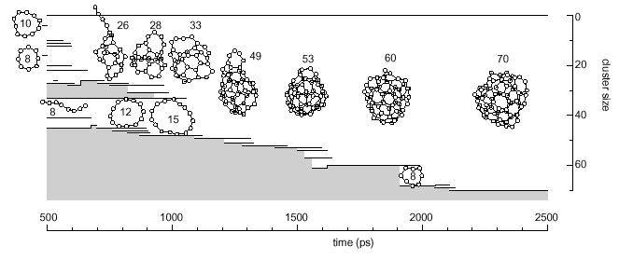
Fig. 5. Formation of a C₇₀ cluster.

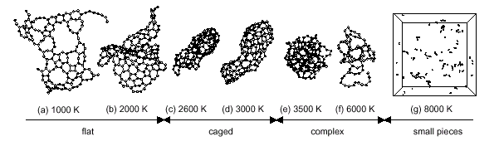
Fig. 6. Temperature dependence of cluster structures.

To save the face, the authors subjected an irregular C₆₀ to a special thermal treatment: they kept this cluster at 2500 K after removing all other atoms and clusters for 222 ns. Here, migrations of pentagons led finally to the structure of a perfect icosahedral fullerene C₆₀ (Fig. 7). The results of computer simulations are summarized in the scheme of fullerene formation shown in Fig. 8. To our mind, this model is too complex and artificial and the reason is not adequate choice of interatomic potentials. Our experience in the field of computer simulations including self-assembly and self-organization of imperfect crystals, amorphous materials, polymers, polymer liquid crystals, and biopolymers [5] led us to conclusion that a key factor in molecular dynamics modeling is the choice of interatomic potential.

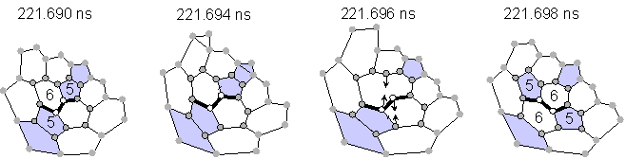

Fig. 7. Rearragement of atoms and formation of a perfect structure during annealing.
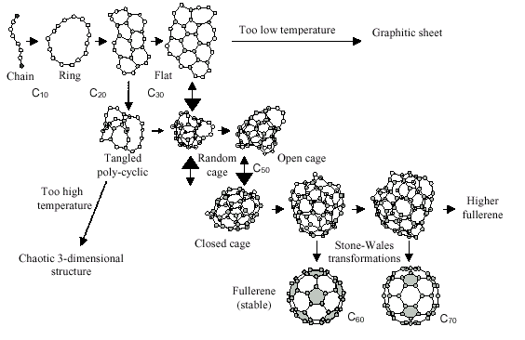
Fig. 8. Fullerene formation model.

4. NEW MOLECULAR DYNAMICS MODEL OF CHARGES AT BONDS
4.1. Interelectronic, interatomic, and electron-atom interactions

In ab initio molecular dynamics, the problem of interatomic potentials is solved as follows [5]. Lagrange equations of the first kind are integrated numerically for electronic degrees of freedom, where the wave functions of the ground state act as generalized coordinates and the undetermined Lagrangian multipliers are fitting parameters. At same time, the potential well is calculated for atoms whose motion is described by the classical equations of Newtonian mechanics. This approach, which was proposed by Car and Parrinello in 1985, has been successfully used to study the atomic and electronic properties of disordered systems, in which the structure was previously unknown, bit its implementation requires extensive computer resources, so that it is outside the scope of most researchers. In many cases, constraints imposed on the system of atoms and electrons are known before the computer simulations are performed as a result of theoretical reasoning or real experiments. This allows us to construct simpler molecular dynamics compared with that proposed by Car and Parrinello. The new approach takes into account the contribution of the electronic subsystem if the electrons are not only in the ground state but also gives the possibility to incorporate the excited states formed by electronic transitions [6].
Let us consider a C₆ ring molecule (Fig. 9). To simulate interactions between the atoms, we use topological pair potentials [7, 8] in the form of the anharmonic Morse potential
$$U=U_{0}\left(e^{−2α\left(r−r_{0}\right)}−2e^{−α\left(r−r_{0}\right)}\right)$$
Here $U_{0}$ is the dissociation energy, $r_{0}$ is the equilibrium distance between considered neighbors, and $α^{2} U_{0}$ is the force constant. It is convenient to divide the interaction potentials for such a molecule into the following four groups.
The first group includes potential describing interactions between atoms connected by covalent bonds. We take the following parameters for this potentials: $U_{0}=5\text{.}5 \text{eV}, r_{0}=1\text{.}\text{56}$Å ,$α=\text{13}\text{.}6$Å⁻¹.
The second group of potentials describes interactions between atoms that are separated by two covalent bonds, so called bond-angle potential. We denote this by the following symbol C(-C-)C. Here, the symbols on the extreme left and right correspond to the interacting atoms, the symbol in brackets show a path in topological space of covalent bonds which connets these atoms. The parameters for these potentials are: $U_{0}=0\text{.}5 \text{eV}, r_{0}=2\text{.}\text{62}$Å ,$α=\text{13}\text{.}6$Å⁻¹. The distance $r_{0}$ for this group is selected in such a manner that the tetrahedral angle between adjacent bonds corresponds to the minimum of interaction potential energy.
The third group of potentials takes in account the contribution to the potential energy of a molecule from rotation of adjacent links with respect to each other, i.e. C(-C-C-)C torsional vibrations. To simulate this potential relief, we use the following parameters: $U_{0}=0\text{.}1 \text{eV}, r_{0}=3\text{.}\text{12}$Å ,$α=\text{13}\text{.}6$Å⁻¹.
The reasons for such a choice are discussed at greater length elsewhere [bb]. The cutoff radii were equal to $r_{\text{cut}}=7\text{.}0, 7\text{.}5, \text{and} 9\text{.}0$ Å, respectively.

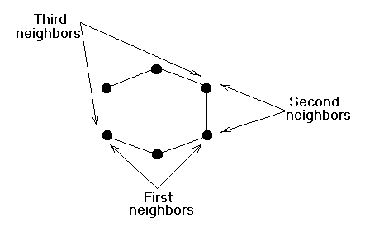
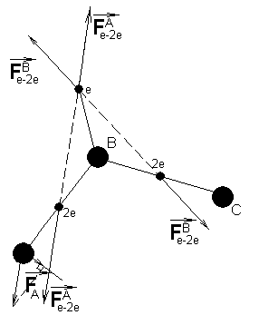

Fig. 9. Scheme of topological interactions in a C₆ ring molecule. Fig. 10. Interactions in an electronic subsystem.

The fourth group of potentials takes in account interactions between atoms and electrons. It is known that in compounds, carbon atoms have four bonding (shared) electron pairs that are separated by the greatest possible distance [10]. We suppose that in fullerene structures carbon atoms have three bonding electron pairs and one nonbonding (unshared) electron. We placed the bonding electron pairs at the centers of the covalent bonds and the unshared electrons at approximately the same distance from the carbon atoms on the C_{3V} axis of symmetry (Fig. 10). Each system of a carbon atom and an unshared electron is considered as a rigid rotator. The forces acting on electrons were transferred to the relevant atoms according to the laws of classical mechanics (Fig. 10). To model electron repulsion, we used the Coulomb potential without a cutoff radius. It is worth to note that the calculation of long-range coulomb interactions without a cutoff radius takes proper account of electron correlation.
The classical equations of motion for the atomic and electronic subsystems were integrated numerically by the Nordsieck method to the fifth order of accuracy using a procedure described in our previous studies. A fundamental difference is that previously, with one exception [dd], we only considered the atomic subsystem whereas in this fullerene study we investigated both subsystems simultaneously. Since electrons are more mobile, a time step for the electronic subsystem was of 1 fs, one order of magnitude less than for the atomic subsystem. To increase the calculation efficiency, a small variation of a rigid rod length (a distance between a carbon atom and an unshared electron) was tolerated. Usually this distance was in the range 0.4 –0.6 R, where R is the length of an interatomic bond.
4.2. Folding flat carbon clusters
In molecular dynamics computer simulations, the amount of information is so immense that we considered only one typical run in detail. In other words, we shall present and discuss structures for one evolution history keeping in mind that other evolution histories are similar and may differ to only a small extent. A flat С₂₄ cluster was taken as a basis. The initial configuration of the cluster is shown in Fig. 11. The large circles represent carbon atoms and the small ones show electrons and electron pairs.
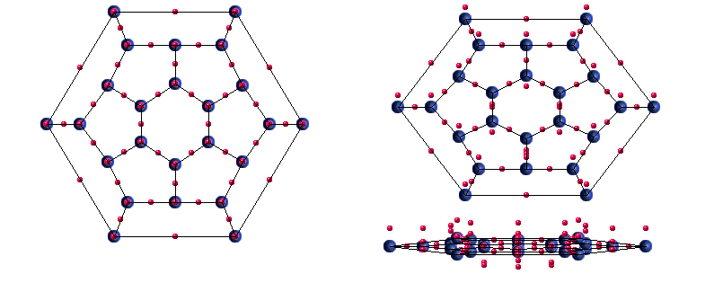

Fig. 11. Initial configuration of a flat C₂₄ cluster from different observation points.

Figs. 12 and 13 show the structure of this cluster after 50 and 150 ps, respectively. One can see that at first the flat cluster has transformed into a perfect semispheroid and then turns into a perfect C₂₄ fullerene. It is worth noting that the configuration of unshared electrons has changed beyond recognition. The electrons were forced out an inner part of the semispheroid and formed a symmetrical sphere layer outside the fullerene.

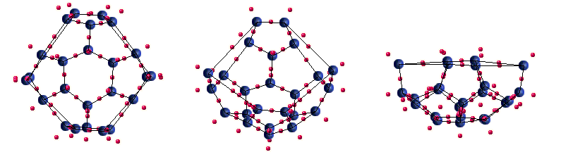
Fig. 12. Configuration of a C₂₈ cluster from different observation points 50 ps later.

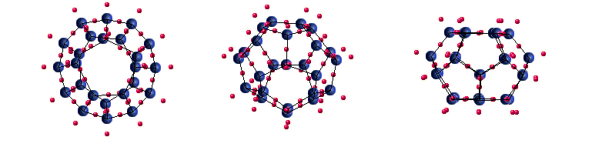
Fig. 13. Final equilibrium configuration of a C₂₈ cluster from different observation points after 150 ps.

To clarify the role of the unshared electrons, we have taken the same initial atomic configuration as previously but have changed the initial electron configuration decreasing the number of electron pairs and increasing the number of unshared electrons at the periphery of the basis cluster (Fig. 14). Once the dynamic equilibrium is established and the flat cluster transformed into a spherical segment of a larger radius (Fig. 15), a tetrahedral C₄ was added on its inner side. As a result, we have obtained an imperfect spheroidal C₂₈ cluster (Fig. 16) that after relaxation had a perfect fullerene shape (Fig. 17).

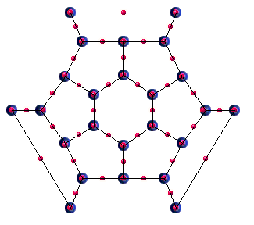
Fig. 14. Modified initial electron configuration
of a flat C₂₄ cluster.

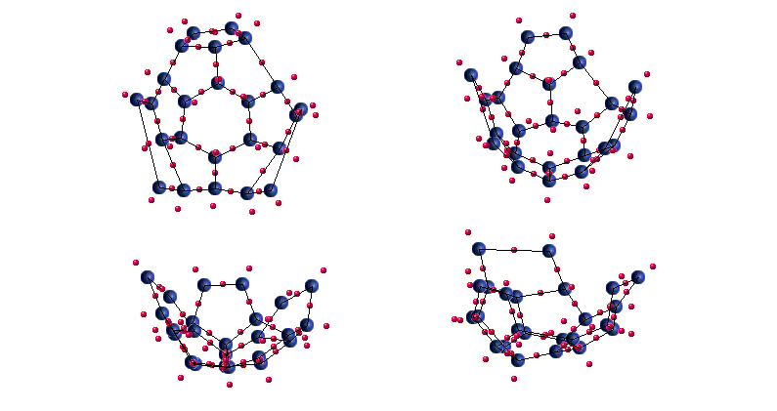
Fig. 15. Spherical segment shape of a C₂₄ cluster from different observation points, 42 ps later.

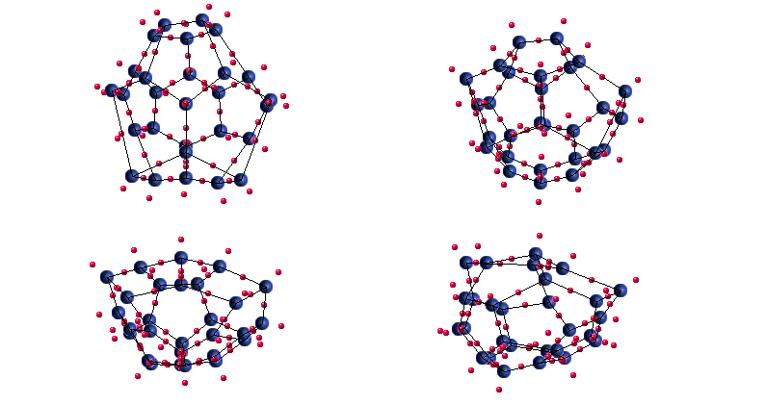
Fig. 16. Imperfect spheroidal C₂₈ cluster from different observation points at 42 ps.

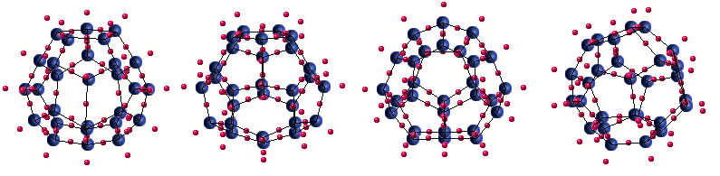

Fig. 17. C₂₈ fullerene from different observation points after 180 ps.

From such calculations it turns out that the initial electron configuration is crucial for a fullerene size during its growth. To make sure that it is really so, we have again changed the electron configuration of an initial flat C₂₄ cluster decreasing the number of electron pairs and increasing the number of unshared electrons at the periphery of the basis cluster (Fig. 18). The same procedure as before with the addition of a C₆ cluster made it possible to obtain a C₃₆ fullerene (Fig. 19). Such evolution of a flat C₂₄ cluster with one and the same atomic configuration but with different electronic configuration of outer carbon atoms provided evidence that electron configuration is a crucial factor in fullerene evolution.

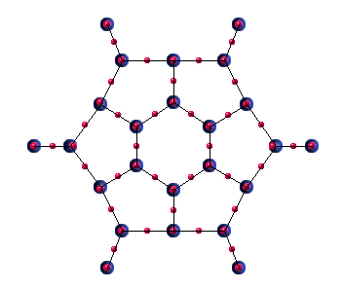
Fig. 18. Initial configuration of a flat C₂₄ cluster
with the maximum of unshared electrons.

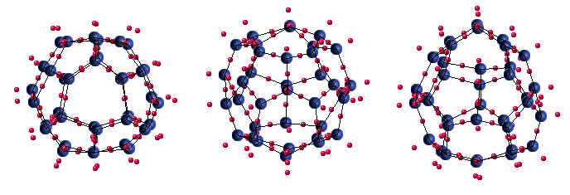
Fig. 19. Final configuration of a C₃₆ fullerene from different observation points after 180 ps.

5. CONCLUSIONS
We have developed a molecular-dynamics computer simulation procedure that allows to study the nucleation, self-organization and structure evolution of fullerenes. The procedure makes it possible to study configuration changes at the electronic level and transfer the information obtained to the atomic level that is closely related with experiment. We suppose that the formation of a perfect spheroid can be considered from two points of view: self-organization of unshared electrons (physical) and continuous space transformation due to the decrease of a space curvature radius (mathematical). It should be mentioned that the approach considered can be applied not only to fullerenes but also to more complicated systems, like nanotubes. Researches of this sort are now in progress.

6. REFERENCES
- S.V. Kozyrev and V.V. Rotkin, “Fullerene. Composition, dynamics of a crystal lattice. Electron structure and properties,” Phys. Solid State, 27(90), 1409-1434 (1993).
- U.E. Lozovik and A.M. Popov, “Formation and propogation of carbon nanostructure,” Uspekhi fiz. Nauk 167(7), 752-760 (1997).
- Yasutaka Yamaguchi and Shigeo Maruyama, “A molecular dynamics simulation of the fullerene formation process,” Chem. Phys. Lett. 286(3-4), 336-342 (1998).
- Shigeo Maruyama and Yasutaka Yamaguchi, “A molecular dynamics demonstration of annealing to a perfect C₆₀ structure,” Chem. Phys. Lett. 286(3-4), 343-349 (1998).
- A.I. Mel’ker, Modeling Experiment (in Russian), Physics Series No. 10, Znanie, Moscow, 1991.
- A.I. Mel’ker, S.N. Romanov, and A.L. Emiryan, “Dynamic model of charges at bonds and inverse transition in ammonia,” Tech. Phys. Lett. 22(100), 806-807 (1996).
- D.V. Soloviev and A.I. Melker, “Formation, structure, and deformation of a polyethylene globule in confined geometry,” Modell. Simul. Mater. Sci. Eng. 6(4), 361-368 (1998).
8. A.I. Melker and D.V. Soloviev, “Molecular dynamics study of polyethylene extension,” in International Workshop on Nondestructive Testing and Computer Simulations in Science and Engineering, Alexander I. Melker, Editor, Proceedings of SPIE Vol. 3687, pp. 132-141 (1999).
- A.I. Melker and A.N. Efleev, “Computer simulation of structure and mechanical properties of polymer liquid crystals,” J. Macromol. Sci.-Phys. B38(5&6), 769-785 (1999).
- R.J. Gillespie, Molecular Geometry, Van Nostrand Reinhold Co. London, 1972.

